SUMMARY OF TEACHERS’ DAY CELEBRATIONS
(05.09.2022 to 09.09.2022)

DEPARTMENT OF BUSINESS ADMINISTRATION
JAMAL MOHAMED COLLEGE (AUTONOMOUS), TIRUCHIRAPPALLI – 20

PROGRAMME – I
Date : SEPTEMBER 05, 2022
Location : BBA Dept., JAMAL MOHAMED COLLEGE, Trichy - 20
Number of Persons Attending : 100 Students
Chief Guest : Dr. S. ISMAIL MOHIDEEN (Principal)
Dr. A. MOHAMED IBRAHEEM (Vice - Principal)
Dr. M. MARIMUTHU (Co-Ordinator of BBA Department)
Dr. M. RADHAKRISHNAN (MID of BBA Department)

PROGRAMME SUMMARY

On 5th September, 2022 (Monday), Department of Business Administration of Jamal Mohamed College at Trichy, organized Teachers’ Day celebration. The function took place in the Department itself. The departments were beautifully decorated by the students for ‘Teachers’ Day. The students of various sections, along with the help of the Business Administration Association office bearers have organized a function for the teachers. The Co-ordinator was also present in the function. The program started with the Co-ordinator, Member-in-Charge and the Faculties of the Department. The function was highlighted featuring Cake cutting and felicitation ceremony was held along with the Dias with the respected faculties.

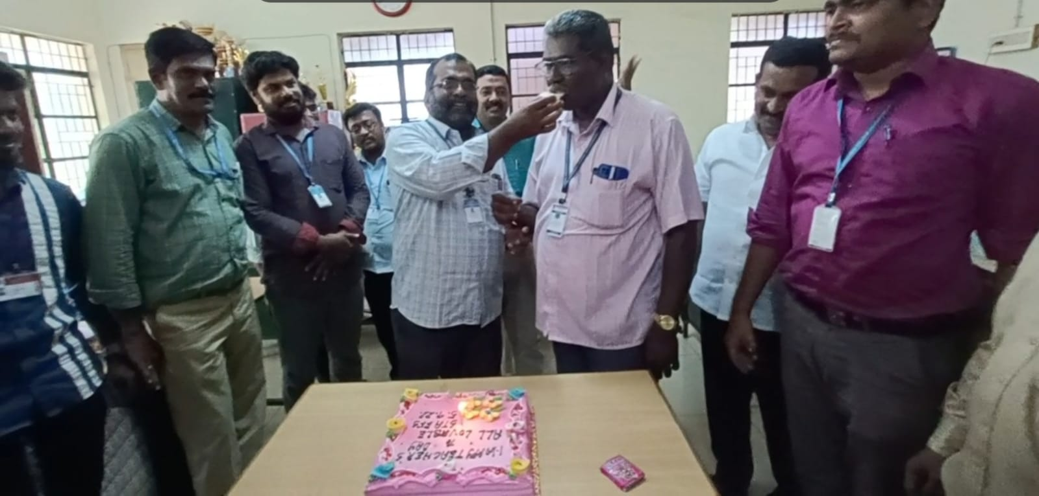

Cake Cutting Celebrations held in BBA Men Staff Room at 05.09.2022

PROGRAMME – I I
(BOOK READING SESSION)

Date : SEPTEMBER 05, 2022
Location : JAMAL MOHAMED COLLEGE, Trichy - 20
Number of Persons Attending : 60 Students
Conducted by : Dr.I. ABBAS KHAN

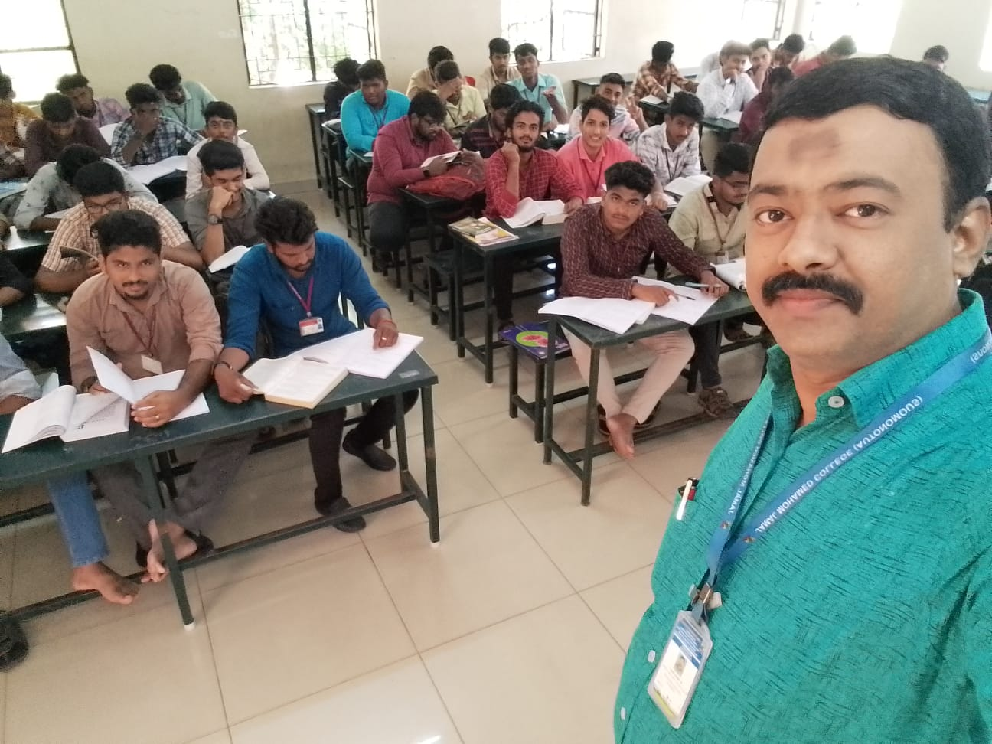

It was held at JMC BBA Class Room at 05.09.2022

There was a “Book Reading Session” as well, conducted by the BBA Students of Jamal Mohamed College, Trichy, which involved the students to reading Library books.

PROGRAMME – I II
(TREE PLANTATION PROGRAMME)

Date : SEPTEMBER 05, 2022
Location : JAMAL MOHAMED COLLEGE, Trichy - 20
Number of Persons Attending : 50 Sponsoring
Chief Guest : Dr. S. ISMAIL MOHIDEEN (Principal)
Dr. A. MOHAMED IBRAHEEM (Vice - Principal)
Dr. M. MARIMUTHU (Co-Ordinator of BBA Department)
Dr. M. RADHAKRISHNAN (MID of BBA Department)

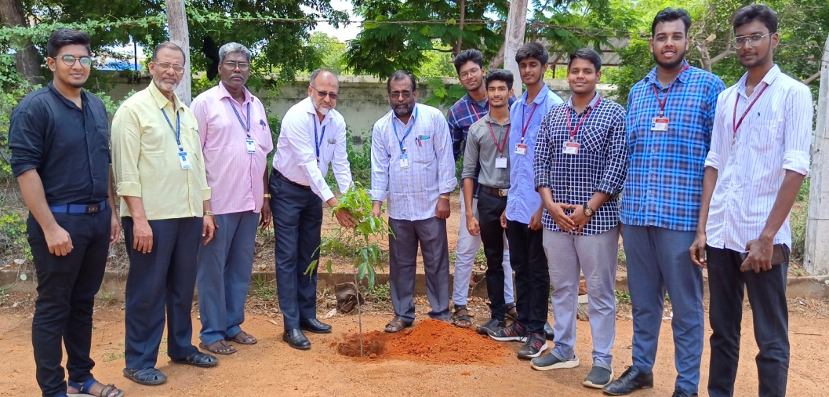

There was a “Tree Plantation Function” as well, conducted by the BBA Students of Jamal Mohamed College, Trichy, which involved higher officials like “PRINCIPAL, VICE PRINCIPAL, CO-ORDINATOR and MEMBER INCHARGE” where they gave their presence and harvested their time and energy for the plantation function, that has created an awareness and impact among students and members of other department as well, the students had meaningful time in the after hand.

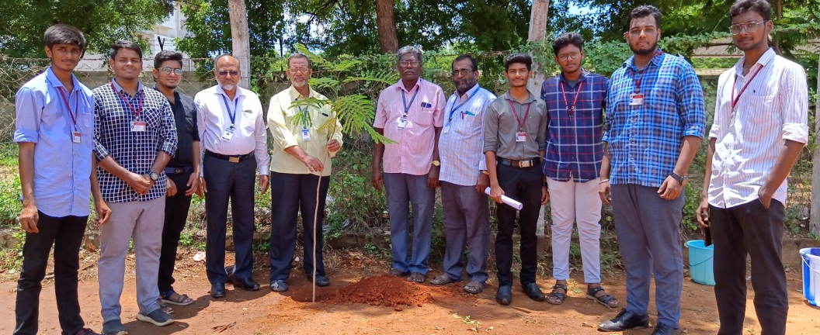
It was held at JMC Play ground at 05.09.2022
PROGRAMME – I II
(SPECIAL LECTURE PROGRAMME)
Date : SEPTEMBER 06, 2022
Location : JAMAL MOHAMED COLLEGE, Trichy - 20
Number of Students Attending : 150 Students
Chief Guest : Dr. T.SELVARAJU,
Associate Professor
Department Of Tamil
Jamal Mohamed College
Trichy

There was a “Special Lecture Programme” as well, conducted by the BBA Association of Jamal Mohamed College, Trichy, which involved higher officials like “ASSISTANT SECRETARY, CO-ORDINATOR and MEMBER INCHARGE” where they gave their presence and harvested their time and energy for teachers day special lecture programme, that has created an awareness and impact among students and members of other department as well, the students had meaningful time in the after hand.

It was held at AL MANHAL Seminar Hall at 06.09.2022

